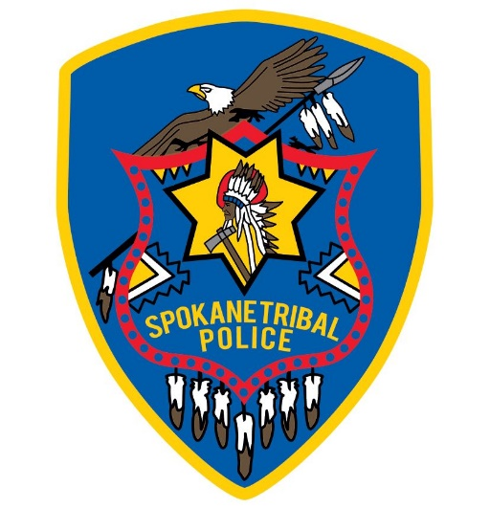

Spokane Tribal Police
December Report 2022

December brought out the best in Mother Nature as we experienced Snowmageddon 2022. With all hands on deck, the Spokane Tribal Police Department was pulling vehicles out of ditches, responding to calls, and getting stuck ourselves. There were no injury accidents reported during the heavy snowfall on our roads.
Our Communications Center was flooded with calls for frozen pipes, collapsing roofs, and assistance calls from our community members. They worked diligently to keep up with the extra call volume and making sure that everyone was taken care of.
The new computer server for the upgrade to our Spillman System has been installed and the migration of our old server to the new is now being done. This replacement of outdated equipment will enable the department to deploy the laptops to the vehicles in January 2023.

The January Entry Level Police Officer hiring process will begin with applications being accepted to Human Resources. Spokane Tribal members are encouraged to apply.
Applications for Communications Specialist are being accepted now!

Remember, our Drug Tip line is answered by the drug detective only.
Your anonymity is safe. Please, if you see something, say something.

Our entire community needs to help, it is making a difference!
Drug Tip Line 509-202-5541

